Project Design Phase
Problem – Solution Fit Template
Date | 15 February 2025
Team ID
Project Name | Script-Controlled ACL – Restrict Record Access Based on Field Value
Maximum Marks | 2 Marks
Problem – Solution Fit Template:
The Problem-Solution Fit simply means that you have found a problem with your customer and that the solution you have realized for it actually solves the customer’s problem. It helps entrepreneurs, marketers and corporate innovators identify behavioral patterns and recognize what would work and why
Purpose:
❑ Solve complex problems in a way that fits the state of your customers.
❑ Succeed faster and increase your solution adoption by tapping into existing mediums and channels of behavior.
❑ Sharpen your communication and marketing strategy with the right triggers and messaging.
❑ Increase touch-points with your company by finding the right problem-behavior fit and building trust by solving frequent annoyances, or urgent or costly problems.
❑ Understand the existing situation in order to improve it for your target group.

Template:
Define CS, fit into CC | 1. CUSTOMER SEGMENT(S) CS  Who is your customer? i.e. working parents of 3-5 y.o. kids  - ServiceNow administrators responsible for data security  - ServiceNow developers who write and maintain ACLs  - Service desk agents / end users who work on the records | 6. CUSTOMER CONSTRAINTS CC  What constraints prevent your customers from taking action or limit their choices of solutions? i.e. spending power, budget, no cash, network connection, available devices.  - Standard ACL conditions cannot evaluate record-specific field values without a script  - Limited visibility for debugging ACL scripts  - Results depend on ACL evaluation order, roles and live field values | 5. AVAILABLE SOLUTIONS AS  Which solutions are available to the customers when they face the problem or need to get the job done? What have they tried in the past? What pros & cons do these solutions have? i.e. pen and paper is an alternative to digital notetaking  - Role-based ACLs: simple, but give every role holder access to all records in the table  - Standard ACL conditions: cannot check record-specific field values  - Manual testing by impersonation and log review: slow, and errors are hard to trace | Explore AS, differentiate
Focus on J&P, tap into BE, understand RC | 2. JOBS-TO-BE-DONE / PROBLEMS J&P  Which jobs-to-be-done (or problems) do you address for your customers? There could be more than one; explore different sides.  - Restrict access to records based on the value of a field (e.g., Confidential)  - Write a script-controlled ACL that allows or denies access correctly  - Let users open only the records they are authorized to see and work on | 9. PROBLEM ROOT CAUSE RC  What is the real reason that this problem exists? What is the back story behind the need to do this job? i.e. customers have to do it because of the change in regulations.  - Role-based ACLs are too coarse for record-level rules  - ACL scripts depend on evaluation order, roles and live field values  - Script rules and exceptions are not defined or applied consistently | 7. BEHAVIOUR BE  What does your customer do to address the problem and get the job done? i.e. directly related: find the right solar panel installer, calculate usage and benefits; indirectly associated: customers spend free time on volunteering work (i.e. Greenpeace)  - Writes ACL scripts that check a field value using current.<field>  - Sets answer = true / false based on user role and field value  - Tests with impersonation and different roles, and reviews ACL evaluation order and system logs | Focus on J&P, tap into BE, understand RC
Identify strong TR & EM | 3. TRIGGERS TR  What triggers customers to act? i.e. seeing their neighbour installing solar panels, reading about a more efficient solution in the news.  - Manager or auditors ask that sensitive records are visible only to the right people  - Sensitive records show up in lists and reports  - A user reports “I can’t open my own ticket!” | 10. YOUR SOLUTION SL  If you are working on an existing business, write down your current solution first, fill in the canvas, and check how much it fits reality. If you are working on a new business proposition, then keep it blank until you fill in the canvas and come up with a solution that fits within customer limitations, solves a problem and matches customer behaviour.  - Script-controlled ACLs in ServiceNow for READ, CREATE, WRITE and DELETE  - Each script checks current.<field> and the user’s role, then sets answer = true or false  - Only authorized users see records with the restricted field value, and record owners are not wrongly denied | 8.1. ONLINE CH  What kind of actions do customers take online? Extract online channels from #7  - ServiceNow instance: ACL list and script editor, Impersonate User, System Logs, record lists and reports | Extract online & offline CH of BE
Identify strong TR & EM | 4. EMOTIONS: BEFORE / AFTER EM  How do customers feel when they face a problem or a job and afterwards? i.e. lost, insecure > confident, in control - use it in your communication strategy & design.  - Before: worried, exposed to data-leak risk, anxious, uncertain, confused and frustrated  - After: confident in audits and compliance, in control with least-privilege access |  | 8.2. OFFLINE CH  What kind of actions do customers take offline? Extract offline channels from #7 and use them for customer development.  - Audit reviews and discussions with the manager, auditors and colleagues  - Team coordination on ACL rules and exceptions | Extract online & offline CH of BE
References:
- https://www.ideahackers.network/problem-solution-fit-canvas/
- https://medium.com/@epicantus/problem-solution-fit-canvas-aa3dd59cb4fe

Project Design Phase
Proposed Solution Template
Date | 15 February 2025
Team ID
Project Name | Script-Controlled ACL – Restrict Record Access Based on Field Value
Maximum Marks | 2 Marks
Proposed Solution Template:
Project team shall fill the following information in the proposed solution template.
S.No. | Parameter | Description
1. | Problem Statement (Problem to be solved) | Role-based ACLs give every role holder access to all records in a table, and standard ACL conditions cannot check a record’s field value without a script. Administrators worry about data leaks, developers find ACL scripts hard to test and debug, and end users are sometimes denied their own records or see records they should not (PS-1 to PS-3).
2. | Idea / Solution description | Build script-controlled ACLs in ServiceNow that check a field value (e.g., Confidential) with current.<field> and the user’s role, and set answer = true or false. They are created for the READ, CREATE, WRITE and DELETE operations on a custom table, in seven milestones: users and roles, table, the four ACLs, and the conclusion. The ACLs are tested by impersonating users with different roles and by reviewing the system logs.
3. | Novelty / Uniqueness | Access is controlled at the record level by the live value of a field, not only by the user’s role. The same script pattern is applied to all four operations and checked for every role through impersonation.
4. | Social Impact / Customer Satisfaction | Sensitive records are visible only to the right people, which lowers the risk of data leaks and gives confidence in audits and compliance. Authorized users can open the records they need, so there are fewer support tickets about access issues.
5. | Business Model (Revenue Model) | No direct revenue is planned. The value is lower data-leak and audit risk and less support effort for an organization that uses ServiceNow. The ACL configuration can be reused by other ServiceNow teams.
6. | Scalability of the Solution | The same script pattern can be reused for other tables, fields and roles without redesign, and it runs on the ServiceNow cloud platform.

Project Design Phase
Solution Architecture
Date | 15 February 2025
Team ID
Project Name | Script-Controlled ACL – Restrict Record Access Based on Field Value
Maximum Marks | 4 Marks
Solution Architecture:
Solution architecture is a complex process – with many sub-processes – that bridges the gap between business problems and technology solutions. Its goals are to:
- Find the best tech solution to solve existing business problems.
- Describe the structure, characteristics, behavior, and other aspects of the software to project stakeholders.
- Define features, development phases, and solution requirements.
- Provide specifications according to which the solution is defined, managed, and delivered.
Solution Architecture Diagram:
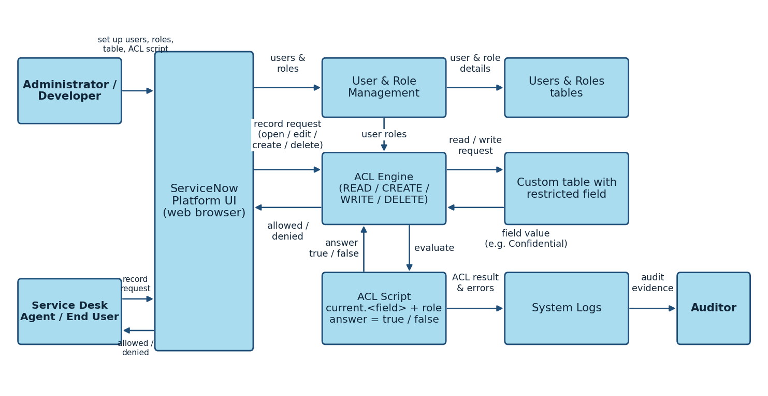
Figure 1: Architecture and data flow of the Script-Controlled ACL solution
Reference: https://aws.amazon.com/blogs/industries/voice-applications-in-clinical-research-powered-by-ai-on-aws-part-1-architecture-and-design-considerations/

